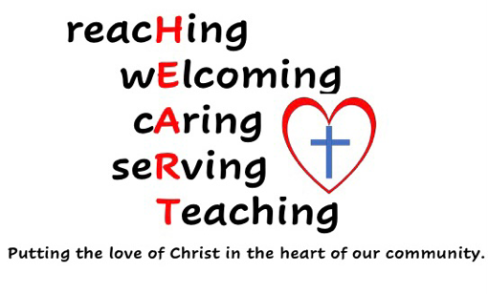
Questionnaire to Guide Strategic Planning Day
The PCC is shortly holding a Strategic Planning Day. For this to be effective, it is important that the PCC is able to review and look realistically at our current situation, so that we can build on our strengths.
The PCC would like to know what you think and feel, rather than relying on its own assumptions about the perspectives of our church community.
Please would you consider completing this questionnaire to help guide our thinking.
Responses can be emailed to admin@winsandchurches.org.uk or printed and delivered to the Church Office or given to your Churchwarden.
You may add your name or answer anonymously. If you email your response, it will be printed and the email deleted & your response remain confidential.
Please return by Wednesday 17th April at the latest.
- WORSHIP (TEACHING)
- What do you really appreciate and value about worship in our churches?
- Are there any changes would you like to see to worship?
- How could you help or participate in these changes?
- GROWING IN FAITH (TEACHING)
- How do you feel the church is helping you to grow in faith?
- What else do you think the Church could be doing to help you grow or deepen your faith?
- How could you help or participate in this?
- HELPING OTHERS COME TO FAITH (REACHING & WELCOMING)
- What do you think the Church does well in helping or encouraging others to come to faith?
- How do you think the Church could encourage others to come to faith and become part of our Church Community?
- How could you help or participate in this?
- ENGAGING WITH THE COMMUNITY (REACHING, SERVING, WELCOMING)
- What do you think is working well in the way our church engages with the local community?
- Is there anything else that you think we could be doing to make our engagement with the local community more effective?
- How could you help or participate in this?
- PASTORAL CARE (CARING)
- How well do you think you are cared for pastorally by the church? What do you think works well?
- Is there anything you would like to see developed in relation to pastoral care?
- How could you help or participate in this?
- COMMUNICATION (REACHING)
- Which forms of communication do you feel are working well in our Churches?
- Are there any ways that communication could be improved within our Churches?
- How could you help or participate in this?
- OTHER
- What other aspects of Church Life do you appreciate and value?
- Is there anything else you would you like to see happening within our Church Communities?
Which of our churches do you attend?

Please feel free to continue on a separate piece of paper if you wish.

Thank you for your support.

Please pray for the members of the PCC that they will have clarity regarding God’s will for our Churches.
Pray that they will be able to recognise what God is already doing and that they will be able to discern areas of strength on which to build and recognise any weaknesses that exist.
Pray for wisdom, grace, energy and guidance, as they seek to put the love of Christ in the heart of our communities.

