‘Fresh Foundations’ Newsletter no 3

Positive news: Our application for Outline Planning Permission has been granted.

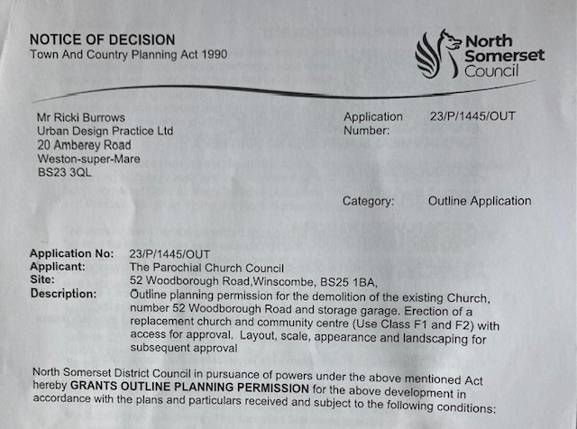

The decision from North Somerset Council ran over the legal time scale by 6 weeks. There are 23 conditions, which we are required to satisfy, and incorporate into our Detailed Design. These conditions are reasonable and will not pose any issues. If you would like a copy, please email Alison alisonparmj@aol.com

How much has this cost?

This Planning Application was agreed by PCC in November 2022. To get us to this stage we have spent £7,600 of the legacy left by Mr Gough. This has paid for the Planning Application, the Architect and Planning Consultant, various reports and surveys. All of the research, consultation, branding, publicity and communication has been carried out by the project team with no costs.

Option 3 which has been granted Outline Planning Permission.

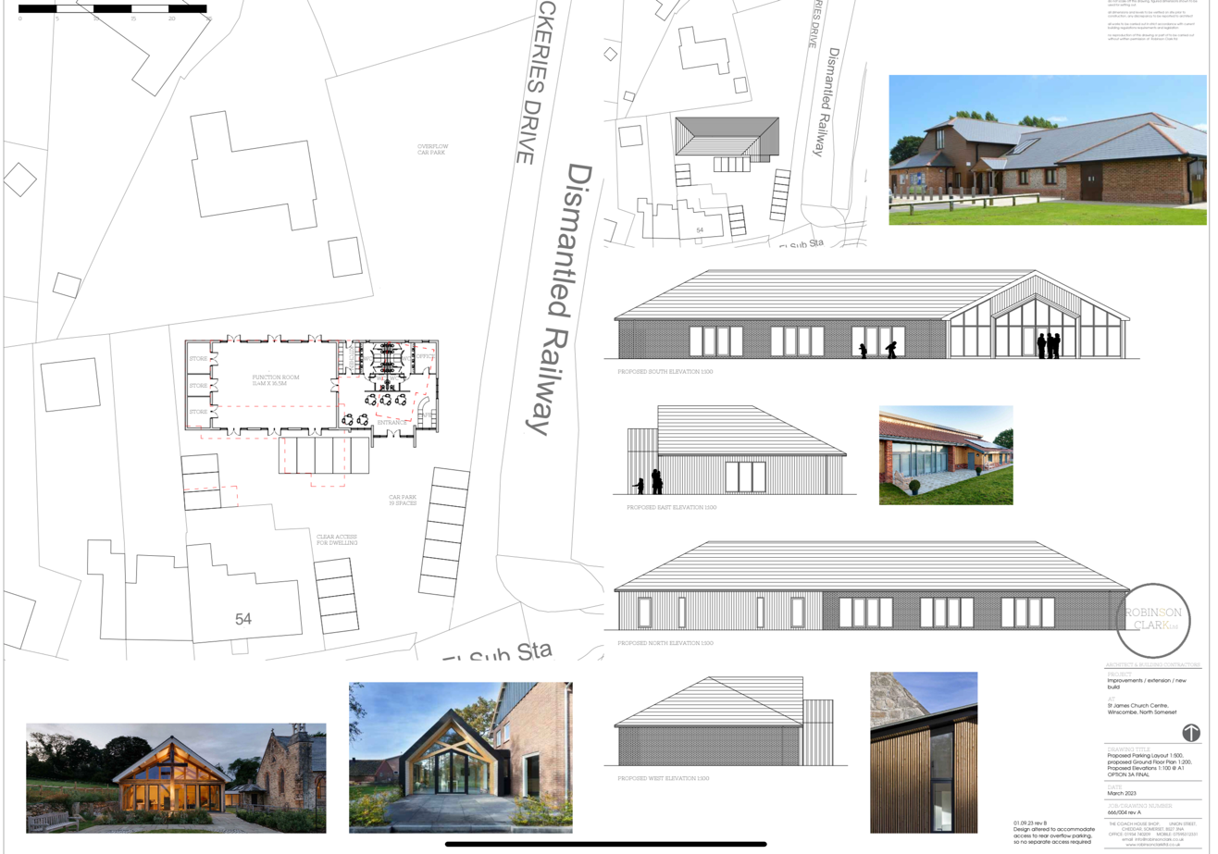

What next?
The team is currently gathering estimates from architects to work on the Detailed Design, which will enable us to have accurate costs from builders and inform the Building Regulation Application.

Fundraising
Now we have the ‘green light’ from North Somerset Council our Grant applications can be submitted. We are currently finalising our Business Case which incorporates all aspects of our vision/aims and future aspirations and will be the core of each of the Grants for which we apply.

The majority of Grants require ‘matched funding’, this means any money the Granting Authority would give, we need to have the same amount to match it or a percentage of it (each grant is different). This needs to come from fund raising events and donations from individuals.

Our aspirations and a beautiful new building can only take place if we can raise enough money. The estimated cost is in the region of £620,00. At our fundraising launch in July 2023 a fuller picture of what we hope to achieve was presented. If you were not able to attend this presentation or would like to know more about the project, please get in touch with the team. Rev Andrew Hiscox, Derrick Claridge, Dorothy Baldwin, Alison Haynes, Jo Claridge, Emma Stocks.

We are now asking for pledges from individuals. If you feel you could pledge any sum would be very welcome. All of you who have already expressed of your intent to donate, thank you and we will be speaking to you in person.

Could you be a prayer warrior?
A prayer evening was held in the Centre on 16th October with members of our 3 Churches attending. We had various prayer stations and one specifically for the Fresh Foundations Project. All of our work is thoroughly ‘wrapped’ in prayer and we are asking for individuals who can support us through prayer and be part of a prayer group that receive information from us about areas of the project that can be prayed for each month. Please let a project team member know if you could help us.

Follow our facebook page: https://www.facebook.com/profile.php?id=100094624851227

