Sermon – Patronal, St James the Great, 25 July 2021
Matt 20: 20-28 The way of St James

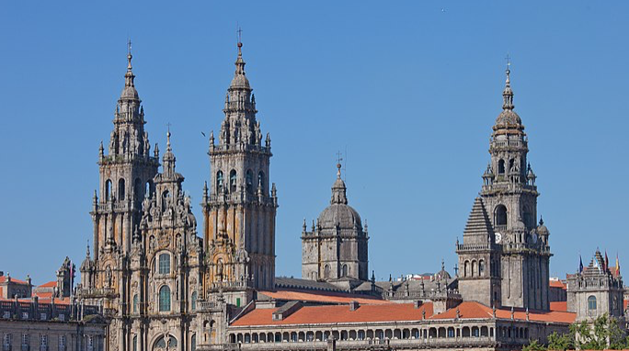 | St James Cathedral at Santiago de Compostela,  Northern Spain.
After the week’s 30C summer heat and thunder storms we arrive at the patronal festival of St James the Great. Heat and thunder are highly appropriate because our Bible reading gives us insight into the character of James – before he became a Saint. It is sometimes noted that people who end up being saints often start out as the opposite! James is one of two sons who operate a fishing business with their father and Simon Peter on the shores of Galilee. Simon, James and John are all young men whom Jesus calls and, leaving their nets and their business interests, they follow Christ. James and John are passionate and zealous and in Mark 3:17 Jesus refers to them as ‘sons of thunder’. This is probably because when a Samaritan village rejected Jesus’ message, it was James and John’s suggestion that Jesus call down fire and thunder from heaven to destroy them (Luke 9:54). So, James and John: nice, peaceable folks. Easy-going, no strong opinions and just the sort of people you want on a PCC! By the time we arrive at Matthew 20 (today’s Gospel reading) it seems James and John have lost little of their zeal and persist in their expectation that Jesus will become a political and military leader and expel the Romans, despite all the many examples of Jesus talking about his kingdom not coming by thunder and force, but by grace. James and John however want to be sure they will be sitting in the important places when the takeover happens. So if you’re strong willed young men, happy to give people the benefit of your opinion, how do you go about influencing Jesus? There is no little humour when…..they get their mum to do it! (Matt 20:21). Perhaps they thought it would be better coming indirectly. Perhaps their mum put them up to it. What we can say is that both mother and sons seem to think this is a good idea: ‘Declare that these two sons of mine will sit at your right and left hand in your kingdom’ (Matt 20:21). Jesus speaks plainly says, ‘You do not know what you are asking, it is not mine to grant, it is for those for whom it has been prepared by my father’(V23). He goes on to explain, yet again, about the nature of his kingdom ‘You know the rulers of the gentiles lord it over them, and their great ones are tyrants. Not so with you – whoever wishes to be great among you must be your servant, and whoever wants to be first must become like a slave, for the son of Man came not to be served but to serve, and give his life as a ransom for many’. It takes the devasting loss of Jesus and the overwhelming joy of Jesus resurrection for James and john to begin to understand about Jesus and his kingdom and become the saints God intended them to be. But it took a long journey and a change of heart to get there. According to Spanish legends, James came to Spain to spread the good news about Jesus there. On returning to Israel, he killed by Herod as predicted in today’s reading. Some believe James’ body was returned to Spain and buried at Compostela. A modern day pilgrimage, the Camino de Santiago, concludes at the Cathedral in Compostela, a route taken by up to a million people take each year. So what do we take from this passage?

Firstly, a challenge. A couple of weeks ago we were talking about how faith has both private and public facing aspects, private in the sense our faith is deeply personal to us but public in the sense that we are called to speak truth to power, a responsibility which we exercise not least with our vote. The James and John in Matthew 20 are quite content to seek out positions of status and power. By contrast, in Christ we see a model of true power and authority which is selfless. Philippians puts it like this: Jesus ‘who, being in very nature God, did not consider equality with God something to be used to his own advantage; rather, he made himself nothing by taking the very nature of a servant, being made in human likeness…Therefore God exalted him to the highest place and gave him the name that is above every name, that at the name of Jesus every knee should bow.’ (Phil 2:6-9). Jesus example prompts us to challenge human models of power, to seek out leaders who will be drawn to the truth, make wise decisions, and not favour one group over another for political advantage or personal gain. We also have a responsibility to pray our leaders, as it says in 1 Tim 2:1-2 ‘I urge, then, first of all, that petitions, prayers, intercession and thanksgiving be made for all people— ² for kings and all those in authority, that we may live peaceful and quiet lives in all godliness and holiness.’

Secondly, an encouragement. A pilgrimage is a physical journey with a spiritual purpose. We see from today’ passage that James and John were on a pilgrimage. When they left their nets to follow Christ they began a journey of discovery on which there were thunder storms and set backs, as well as days of glorious sun. With a pilgrimage you go with purpose, to meet with God. Or as TS Eliot put it, ‘to kneel where prayer has been valid’. We are also on a pilgrimage that requires effort, focus and determination. We may not always feel God is close by. Dare I say it, we may not always find our companions agreeable – especially if they can be like sons of thunder! So let me encourage you to fix your eyes on Jesus, in the knowledge that the kingdom we are striving for is one paved with grace and peace, like the shells of St James pave the Camino de Santiago. And the God whom St James served is faithful and calls us to continue in its shared endeavour.

