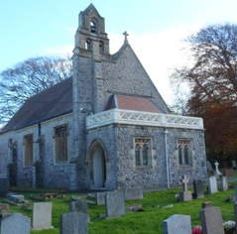
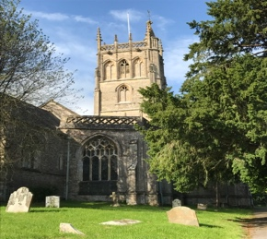
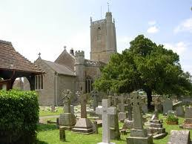
Church of England in Winscombe, Sandford and Churchill
Services in July in the Churches and online
**All are welcome**
Date | St James’s Church Winscombe | All Saints  Sandford | St John’s Churchill | Church Centre  Winscombe  (St James’s Church Hall)
Sunday  4th July |  |  | 8.00 am  BCP Holy Communion | 10.00 am  Family Service*
Tuesday  6th July |  | 10.00 am  Midweek  Communion
Thursday  8th July |  |  |  | 10.00 am  Thursday Church
Sunday  11th July | 9.30 am  Morning Worship & Baptism | 11.00 am  Holy Communion | 11.00 am  Morning Worship & Baptism
Tuesday  13th July |  | 10.00 am  Midweek  Communion
Thursday  15th July |  |  |  | 10.00 am  Thursday Church
Sunday  18th July |  |  | 11.00 am  Morning Worship & Baptism | 10.00 am  Family Holy Communion*
Tuesday 20th July |  | 10.00 am  Midweek  Communion
Sunday  25th July | 09.30 am  Holy Communion  Patronal Festival | 11.00 am  Pandemic Service of Remembrance and Thanksgiving | 15.00 pm  Pandemic Service of Remembrance and Thanksgiving | 15.00 pm  Pandemic Service of Remembrance and Thanksgiving
Tuesday  27th July |  | 10.00 am  Midweek  Communion
Thursday 29th July |  |  |  | 10.00 am  Thursday Church
Facemasks need to be worn to all Services in the Churches and Church Centre
Arrangements may need to be changed in the light of fresh Government Guidance
Please check our website for up to date information
www.winsandchurches.org.uk
*Podcast and Video will also be available

