Sermon – Easter 3, 18th April 2021
Luke 24:36-48 ‘Meeting the risen Christ’
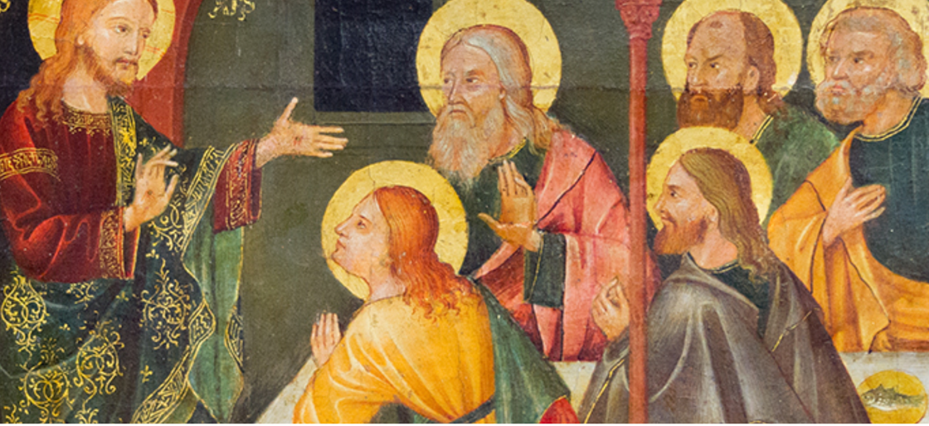
Icon of Christ meeting his disciples, Catholic Church

Some time ago a website was launched in the USA which claimed to offer tickets to heaven. The cost of each ticket was in the $1000’s, but each ticket came with a money-back guarantee. When challenged on the authenticity of the guarantee, the website’s owner allegedly responded, ‘Well, no-one has ever come back to complain!’. Rather than place our faith in false website promises, in the resurrected Jesus we can have sure and certain hope for the future. In our Gospel reading for the third Sunday of Easter, there are four things that the risen Christ does when he meets his newly re-gathered disciples that I think have relevance for us as we begin to re-gather and look to the future of our churches.

Let me offer a little context to begin with. Although we’re in Easter week 3, our Bible reading records events that happened on Easter Sunday, as we pick up the narrative from Luke 24, where the two disciples have just met the risen Jesus on the road to Emmaus. Ever wondered what happened next? Well, Luke’s gospel tells us v33-36: ‘³³ They got up and returned at once to Jerusalem. There they found the Eleven and those with them, assembled together³⁴ and saying, “It is true! The Lord has risen and has appeared to Simon.” ³⁵ Then the two told what had happened on the way, and how Jesus was recognized by them when he broke the bread.’ The Emmaus two immediately leave their lodgings to hurry back to Jerusalem to tell the others, even though they’d settled in for the night. So we find them gathered with all the others, having told of their encounter on the Emmaus road. Consider the frame of mind of the people they meet in Jerusalem: those who had seen their Lord tortured, crucified. On the one hand they’ve locked the doors because they fear the authorities will catch up with them and perhaps imprison or put them to death, like they did with Jesus. On the hand other they’ve heard joyful reports from some who claim to have met the risen Christ, in particular Mary and the Emmaus two, who have just turned up. They were in a place of fear for themselves and for their future, for their safety and their sanity. Then Jesus himself appears in the midst. v37 tells us these disciples were ‘startled and frightened’. But what does he say to them? v36 ‘Peace be with you’ - the assurance of hope and acceptance, of joyful reunion and re-formation, through the gentle and lasting peace only God can give.

The NRSV captures the spirit of the eleven disciples succinctly, v41 ‘in their joy they were disbelieving and still wondering’. This is a wonderful picture of 1st century faith: overwhelmed by joy but still in the presence of doubt. The risen Christ invites them to see and touch his hands and feet; to confirm he is not an apparition or mass hallucination, and when they are still not quite able to take it in, he eats some of their food. The first century Palestine ‘broiled fish’ would be a bit like if he appeared amongst us today and asked for Macdonald’s or ‘fish and chips’, which reminds us that belief in Jesus is a down-to-earth, honest faith, where hope and overwhelming joy and peace mix with a seasoning of doubt.

There is significance in what Jesus goes on to say in V44 “This is what I told you while I was still with you: Everything must be fulfilled that is written about me in the Law of Moses, the Prophets and the Psalms.’ He is joining up his past and present with their future, illustrating the fulfilment of prophecy in the scriptures they knew. Moreover, he is giving their story a new chapter – just when they thought it concluded as a tragedy. Also, in giving them a shared sense of purpose and meaning, he is helping them realise they have a part to play in a bigger story, the grand narrative of God’s enduring love for humanity and the planet. He is giving the inspiration for Hebrews 13:8, ‘Jesus Christ, the same yesterday, today and forever.’ He goes on to explain the mission ahead: the message of ‘repentance and forgiveness of sins’ is to be shared with ‘ all nations, beginning in Jerusalem’ But who is going to do it? v48 tells us: ‘You are my witnesses’, his followers are the key players in this next chapter. And literally St Luke goes on to pen a second volume, the book of Acts, which tells of the coming of the Holy Spirit and God’s Word going out to surrounding nations.
So where does that all leave us on the third Sunday of Easter? Perhaps we feel like the gathered eleven – fearful for the future, anxious for what happens next, wondering about our safety. If we’re in that place, we need to hear afresh the words of comfort spoken by the risen Jesus ‘Peace be with you’, words spoken into our trouble and anxiety. Perhaps we’re like some of those other disciples, we can say our faith can be expressed as deep moments of joy, amazement and hope, but with a seasoning of doubt. Well you’re in good company if you feel this way! It seems that 1st Century faith was not so very different from our 21st century faith in many respects.

Maybe we need to be reminded, like all the disciples, of the shared sense of meaning that only the risen Christ can give. That our lives can have direction and purpose in a world where the overwhelming counter-narrative is ‘survival of the fittest’ and the strongest are expected to lead and win. The Christ who died on the cross but rose again reminds us we have a part to play in the story of God’s love and redemption for the people and the planet, and we work to bring that love about, whether that’s through praying, giving, going, serving, forgiving, loving, reconciling. Where does he ask us to start from? Consider where were those first disciples asked to begin: Jerusalem. It was the place where they were in, the time they were in, the culture they were in. The risen Jesus calls us to reach out and put the love of Christ into the heart of our community here in Winscombe, Sandford and Churchill. Amen.

