Sermon – All Saints 1st Nov 2020 All Saints

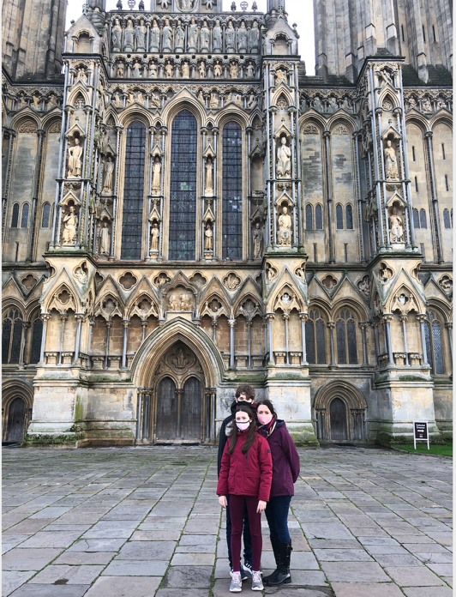 | This week it’s been half term and amidst the monsoon season that is October, we took the kids and the dog to Wells, the smallest city in England. One of the things you can’t miss in Wells is of course the Cathedral, and its West front: Statues of Saints stand in from their alcoves, ascending the sides of the of the church.

We all know the danger in putting things on pedestals – the higher you place them, the further there is to fall! Placing saints on pedestals creates an image of Saints being venerated because of their perfection. Many of our own churches have Stained glass windows depicting Saints such as James or John or St Paul. And we can think of more modern saints like Oscar Romero of San Salvador who took a stand for social justice and was murdered for his faith, or Archbishop Janani Luwum of Uganda who was shot on the orders of Idi Amin, or Mother Teresa who loved the untouchables in the slums of Calcutta

I want to suggest to you they all had something in common, and it’s not that they were all Saints! In fact, if they could talk to us today, they would say they were far from the perfect people their sainthood might imply them to be.

Here’s some words from a very famous Saint: ‘The only credentials I brought to it were invective and witch hunts and arrogance. But I was treated mercifully because I didn’t know what I was doing—didn’t know Who I was doing it against! Grace mixed with faith and love poured over me and into me. And all because of Jesus.
¹⁵⁻¹⁹ Here’s a word you can take to heart and depend on: Jesus Christ came into the world to save sinners. I’m proof—Public Sinner Number One—of someone who could never have made it apart from sheer mercy.’ (1 Tim 1:12-17, The Message).

Elsewhere he wrote ‘For I am the least of the apostles and do not even deserve to be called an apostle, because I persecuted the people of the church of God’ (1 Cor 15:9 NIV)

The person who wrote those words was St Paul.

How do we feel about placing our trust in God today like St Paul did? Perhaps Jesus seems distant, perhaps we feel we could never have a faith like those Saints elevated on pedestals at Wells Cathedral. Perhaps we are undecided: moments of doubt mix with moments when faith seems to make sense of the world around us.

After Mother Teresa died, a number of her letters to a friend were found and initially suppressed. Why? Because they showed her to be a woman of doubt as well as faith, that during her years of service there were times she felt God was near and other when she felt he was distant. There were times when she doubted herself, her own competence and ability to carry on. In the end the letters were released because they show her for what she was – an ordinary person, with everyday feelings, who chose to use her life in service to God, with a doubt that come and go. For Christians, it’s not about getting it right to perfection, perhaps not so much even about faith but more about being faithful to a God we know who loves us as life works itself out.

Carlo Acutis, a 15 year old was recently beatified by the Catholic church. Potential to be first millennial saint – a young teenager who died from Leukaemia but had used what he had – his love of all things technology – whether that was computers, Pokemon, his smart phone, social media in service of the church. He was an ordinary lad who used what he had for Jesus. A bit like that other young lad in Jesus time who also brought what he had – five loaves and two fish- to offer to Jesus as St Luke records for us in his gospel (Lk 9). And Jesus did miracles with it.

A mother and her young daughter were in church and looking at the stained glass window. A shaft of sunlight fell upon the window they were looking through and it made a beautiful reflection on the stone floor below. “Look mummy, said the little girl, Saints are people who let the light through!” And that’s absolutely right. Saints aren’t perfect people who have lived untarnished lived without mistake or fault. They are simply people who choose to let the light in, despite their doubts.

