Sermon – Trinity 18 11th October 2020 All Saints
Ex 32:1-12 The Golden Calf
Have you ever left the room for five minutes only to find the kids or grandkids have seized the moment to create anarchy and chaos? If you’re able to look online today, on our FB Page or Church website, you’ll see a picture which speaks a thousand words. A child stands, scissors in hand, helpfully cutting out faces from paper for her scrapbook. The only problem is, the paper she has used is money! In today’s Bible passage, the Hebrews are left to fend for themselves temporarily whilst Moses and Joshua are absent for forty days, and it also results in anarchy and chaos. I’m conscious the today’s lectionary reading has jumped twelve Chapters since last Sunday’s reading about the Ten Commandments. So let’s briefly recap:
- God appeared to Abraham promising a covenant
- This covenant was extended by God’s faithfulness to Isaac, Jacob, Esau, Joseph. God became the God of their stories too.
- Jacob’s descendants became the Hebrews who were delivered from the hand of their Egyptian oppressors by Moses.
- As a people they escaped into the desert, guided by pillar of cloud by day and fire by night
- God Provided manna and quail for food and water in desert.
- And at last, as they approach the promised land, God laid ground rules (last week Ten Commandments)
- Over Ex 21-31, God renews the covenant with his people. God sets out plans for a Tabernacle, a kind of OT transportable Church, a visible symbol of God’s continued presence among his people and his covenant with them.
Now Moses and Joshua have gone up a mountain to commune with God. But a bit like the girl in the picture, the people take matters into their own hands. But what was done in the picture in innocence, by contrast is a deliberate action by the Hebrews: ‘Come let’s make gods for ourselves who shall go before us….as for this fellow Moses, we don’t know what’s become of him’ (v1). How quick they are to dismiss Moses! There is no thought of his safety, no search party, just a desire to put their own needs first.

A teacher once said, ‘if you want to see who the good kids are, just leave the classroom for a minute’. Will the Hebrews remain faithful to God? Moses did not leave them without spiritual leader – Aaron. Unfortunately, rather than leading them even when it meant doing what was not popular, Aaron bends to the will of the people. He gives in to their desire to have visible symbol of God’s presence among them, and casts it for them in the shape of a golden calf (v4). Couldn’t they see it was just the work of their hands, and had now power at all? It was just their melted down jewellery (v2). In the people’s desire we see reflected a very human tendency, one that we can recognise in society around us and occasionally in ourselves. That’s why this Bible passage can speak to us today. That temptation is simply this: to substitute the material for the spiritual. Why? Because it serves their own needs very nicely to have control over this golden god to whom they can attribute their fortune. What material gods might our generation fashion for itself? A house? 301K/Pension Fund? Social status?
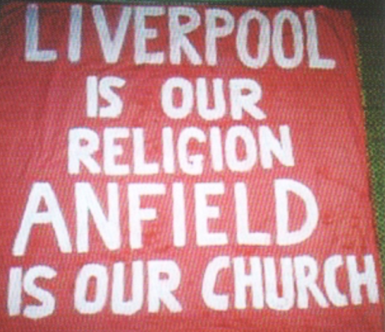 | Some time ago there was a song written about football: ‘Wave your hands wave your hands, Here we stand here we stand, Football is alive, Football is our religion. It sounds very much like a chorus we might sing in Church! ’
Now there’s absolutely nothing wrong with deriving pleasure and enjoyment from the material, such as football; the issues occur when we venerate the material at the expense of the eternal. When we gain more of our identity from these material things than we do from being a child of God. We naturally spend time with others who share our interests, which can result in a sort of ‘echo chamber’ where no one steps in to say what we’re doing is out of line, like Moses has to do with the Hebrews. The Hebrews thought God and Moses had deserted them. It’s hard sitting here, at a distance from each other, wearing masks, or joining in online when we’d ideally like to be there in person. I know sitting at a distance may sometimes underline the loneliness we feel. It may feel like God is distant. God hadn’t deserted the Hebrews, despite how it felt to them. He was still the God of their Story as He is the God of our story today. Sometimes isolation and uncertainty may tempt us to stray away from faith, or to place our trust more in material things. God remains faithful however, and is with us even when we feel how we meet isn’t ideal, whether that’s at a distance, with a mask on, over the internet. If you take one thing from this service this morning, remember this: wherever you are, whatever you are doing, God loves you, in His eyes you are his beloved child and he is with you today and always, His grace and love remain there for us even when he might appear to be temporarily absent. He walks by our side.

